SAMPLE VETTING CHECKLIST (adapted from DSACT of Austin, Texas):
 | Yes | No | n/a
Criteria
Project has a benefit to the Down syndrome community
Identification of the condition, disease or goal under study
Researchers use current, family-focused and positively-positioned terminology in recruitment, consent, and explanation materials
Researchers do not use of outdated terms or concepts (e.g., individuals with Down syndrome are always happy, “special” people, “angels”, vulnerable, etc.)
Study/trial/survey includes correct references to current, respected resources
Study/trial/survey has been approved by IRB, ERB
Study/trial/survey has adequate privacy protections in place (e.g. anonymizes participant data, or clearly states reason for not doing so)
Any compensation is simply stated, commensurate to effort, and is not overly emphasized
Study/trial/survey does not claim that participating will improve, cure, or treat any condition
No person can be excluded from participating based on being a member of a protected class, unless there is a clearly stated reason (such as studying a particular age group)
For medical or treatment-related research: a medical doctor well-versed with Down syndrome research has reviewed and approved the project and this MD's credentials and contact information are included in project materials
Researcher has submitted: Contact information and credentials of the requestor or the individual who will be the main point of contact for questions
Researcher has submitted: A thorough explanation/description (including time commitment) of the study/trial/survey
Researcher has submitted: Copies of trial/study process, consent forms, participant-facing materials and/or entire survey content
Researcher has submitted: Proof of regulatory oversight (IRB, ERB, etc.)
Researcher has submitted: Outline of participant eligibility parameters, along with any pre-screening criteria
Researcher has submitted: Timeline components of the request (project anticipated start or end date)
Researcher has submitted: Any other relevant information, including IRB-approved images, video, outreach language, and social media and digital channel language, as well as communications intended to be seen/received by health care professionals, other materials intended for a “non-participant” audience (e.g. board)
Researcher has submitted: Contact information and credentials of the requestor or the individual who will be the main point of contact for questions, along with an explanation of how they will manage follow-up
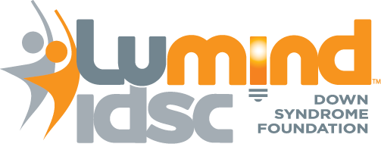
LuMind IDSC www.LuMindIDSC.org
20 Mall Road, suite 200 www.DSCTN.org
Burlington, MA 01803

